**New Wheels Project**

**Introduction to SQL**

# **Problem Statement**

**Business Context**

A lot of people in the world share a common desire: to own a vehicle. A car or an automobile is seen as an object that gives the freedom of mobility. Many now prefer pre-owned vehicles because they come at an affordable cost, but at the same time, they are also concerned about whether the after-sales service provided by the resale vendors is as good as the care you may get from the actual manufacturers.

New-Wheels, a vehicle resale company, has launched an app with an end-to-end service from listing the vehicle on the platform to shipping it to the customer's location. This app also captures the overall after-sales feedback given by the customer.

**Objective**

New-Wheels sales have been dipping steadily in the past year, and due to the critical customer feedback and ratings online, there has been a drop in new customers every quarter, which is concerning to the business. The CEO of the company now wants a quarterly report with all the key metrics sent to him so he can assess the health of the business and make the necessary decisions.

As a data analyst, you see that there is an array of questions that are being asked at the leadership level that need to be answered using data. Import the dump file that contains various tables that are present in the database. Use the data to answer the questions posed and create a quarterly business report for the CEO.

# 

# **Business Questions**

## **Question 1: Find the total number of customers who have placed orders. What is the distribution of the customers across states?**

**Solution Query:**

SELECT COUNT(DISTINCT customer_id) AS total_customers_with_orders

FROM order_t;

SELECT STATE, COUNT(DISTINCT c.CUSTOMER_ID) AS customer_count

FROM customer_t c

JOIN order_t o ON c.CUSTOMER_ID = o.CUSTOMER_ID

GROUP BY STATE

ORDER BY customer_count DESC;

**Output:**

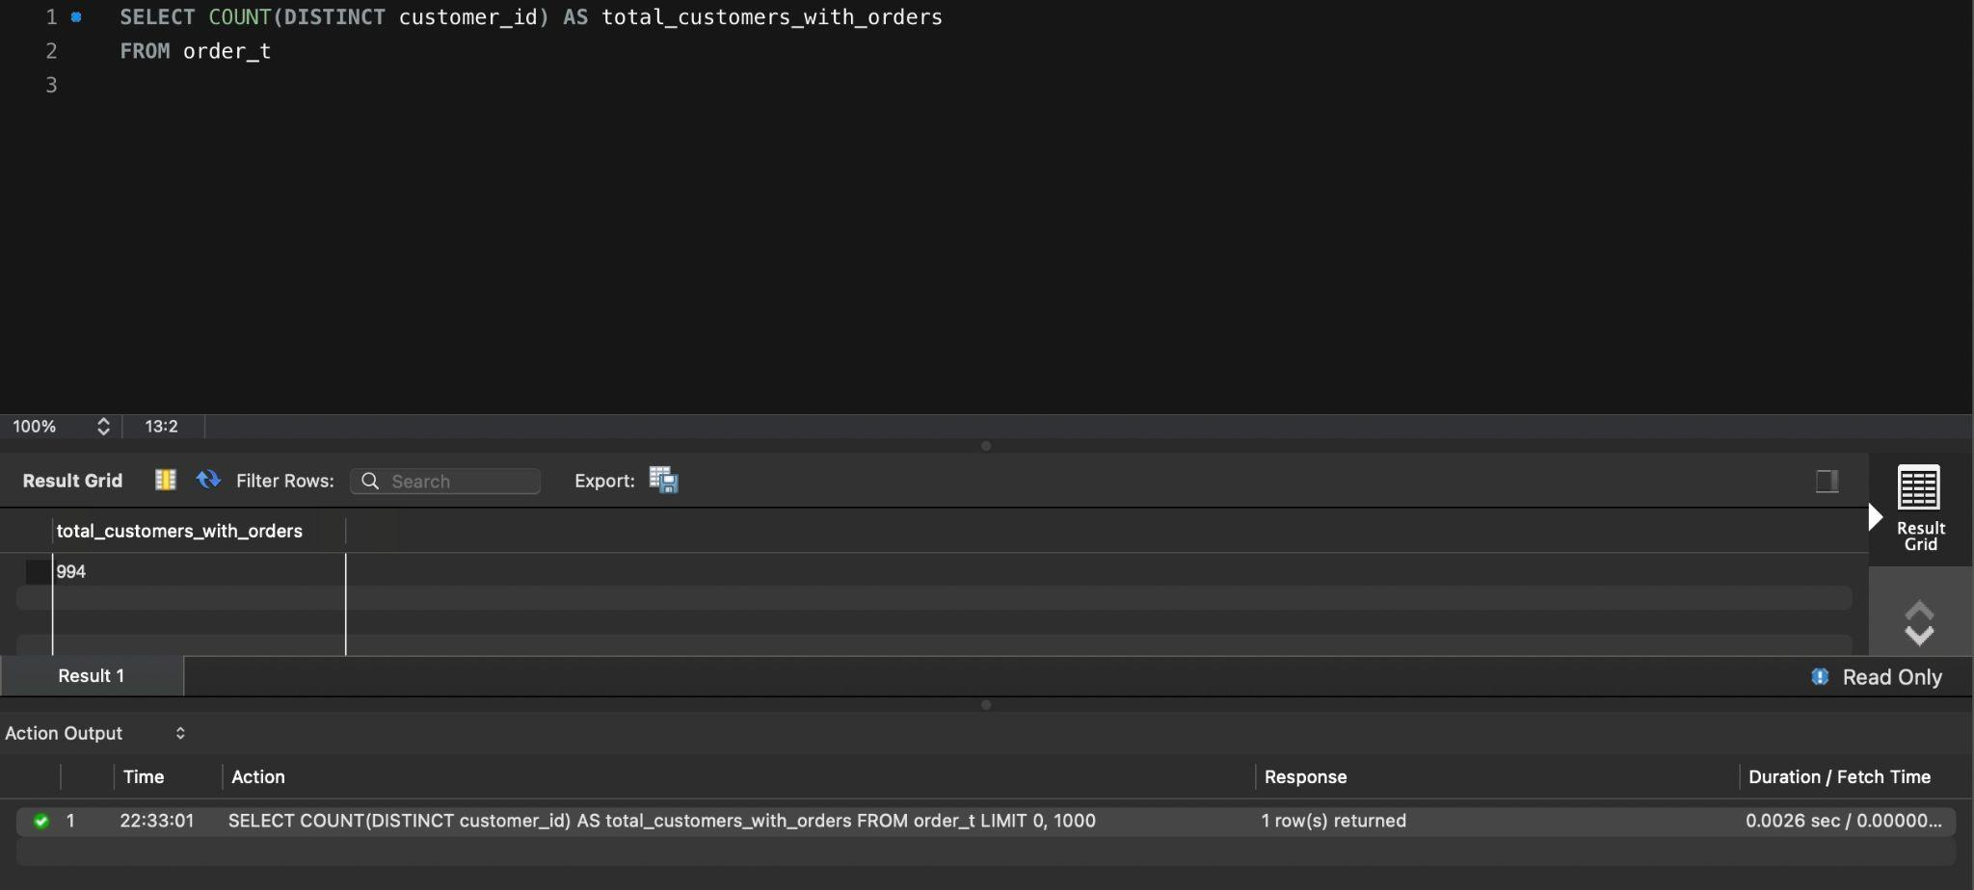

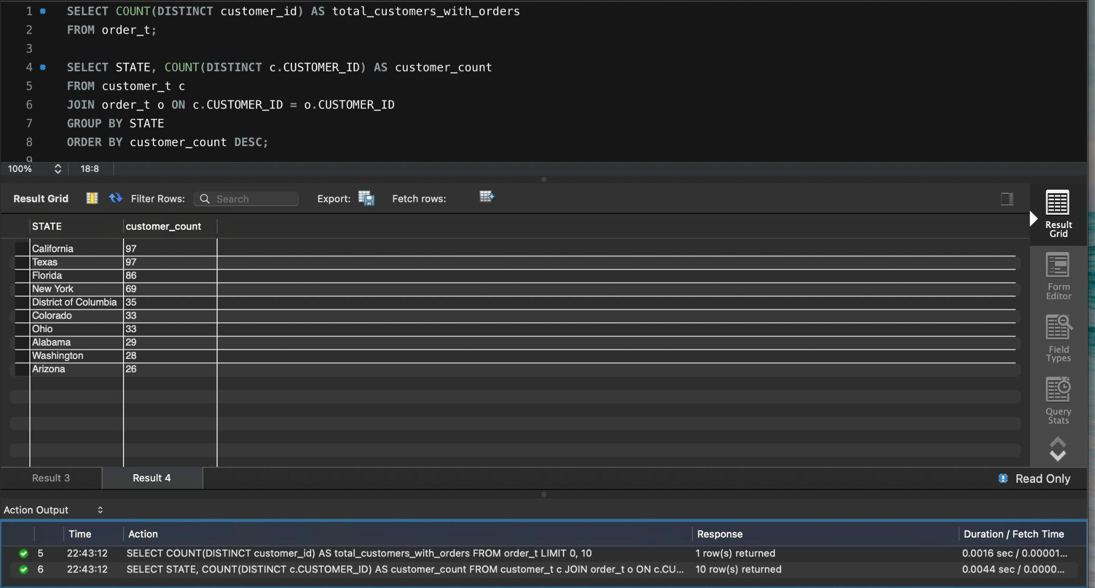

**Observations and Insights:**

* 994 unique customers.
* Strong initial customer base, but given the downward trends, retention strategies are not effective.
* Consider running surveys or post-order satisfaction calls.
* Top states: California (97), Texas (97), Florida (86), New York (69)
* West and South (CA, TX, FL) are major revenue regions.
* Could pilot region-specific campaigns or offers in high-density zones.

## **Question 2: Which are the top 5 vehicle makers preferred by the customers?**

**Solution Query:**

SELECT p.VEHICLE_MAKER, COUNT(DISTINCT o.CUSTOMER_ID) AS customer_count

FROM order_t o

JOIN product_t p ON o.PRODUCT_ID = p.PRODUCT_ID

GROUP BY p.VEHICLE_MAKER

ORDER BY customer_count DESC

LIMIT 5;

**Output:**

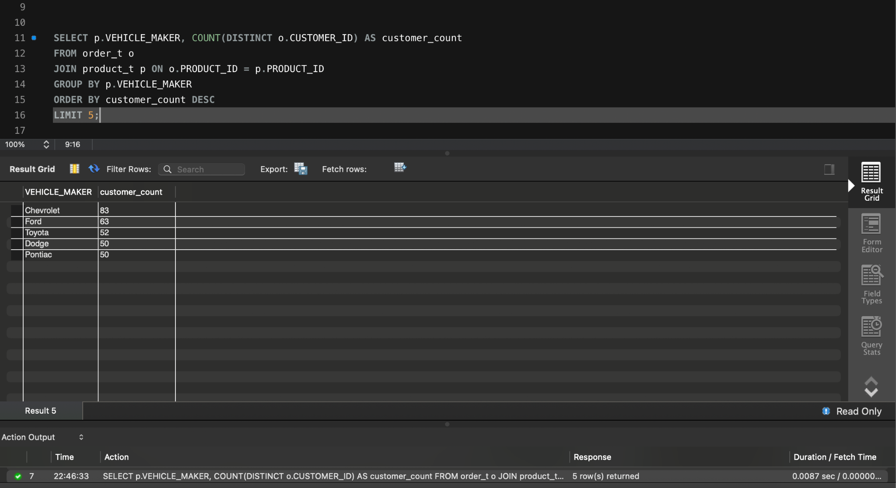

**Observations and Insights:**

* Chevrolet leads with 83 customers, followed by Ford (63), Toyota (52), Dodge (50), Pontiac (50).
* Focus future stock, ads, and support on these makers.
* Could also bundle maintenance or service packages to enhance customer loyalty.

## **Question 3: Which is the most preferred vehicle maker in each state?**

**Solution Query:**

SELECT STATE, VEHICLE_MAKER, customer_count

FROM (

SELECT c.STATE, p.VEHICLE_MAKER, COUNT(DISTINCT o.CUSTOMER_ID) AS customer_count,

RANK() OVER (PARTITION BY c.STATE ORDER BY COUNT(DISTINCT o.CUSTOMER_ID) DESC) AS rnk

FROM order_t o

JOIN customer_t c ON o.CUSTOMER_ID = c.CUSTOMER_ID

JOIN product_t p ON o.PRODUCT_ID = p.PRODUCT_ID

GROUP BY c.STATE, p.VEHICLE_MAKER

) AS ranked_data

WHERE rnk = 1 ORDER BY customer_count DESC;

**Output:**

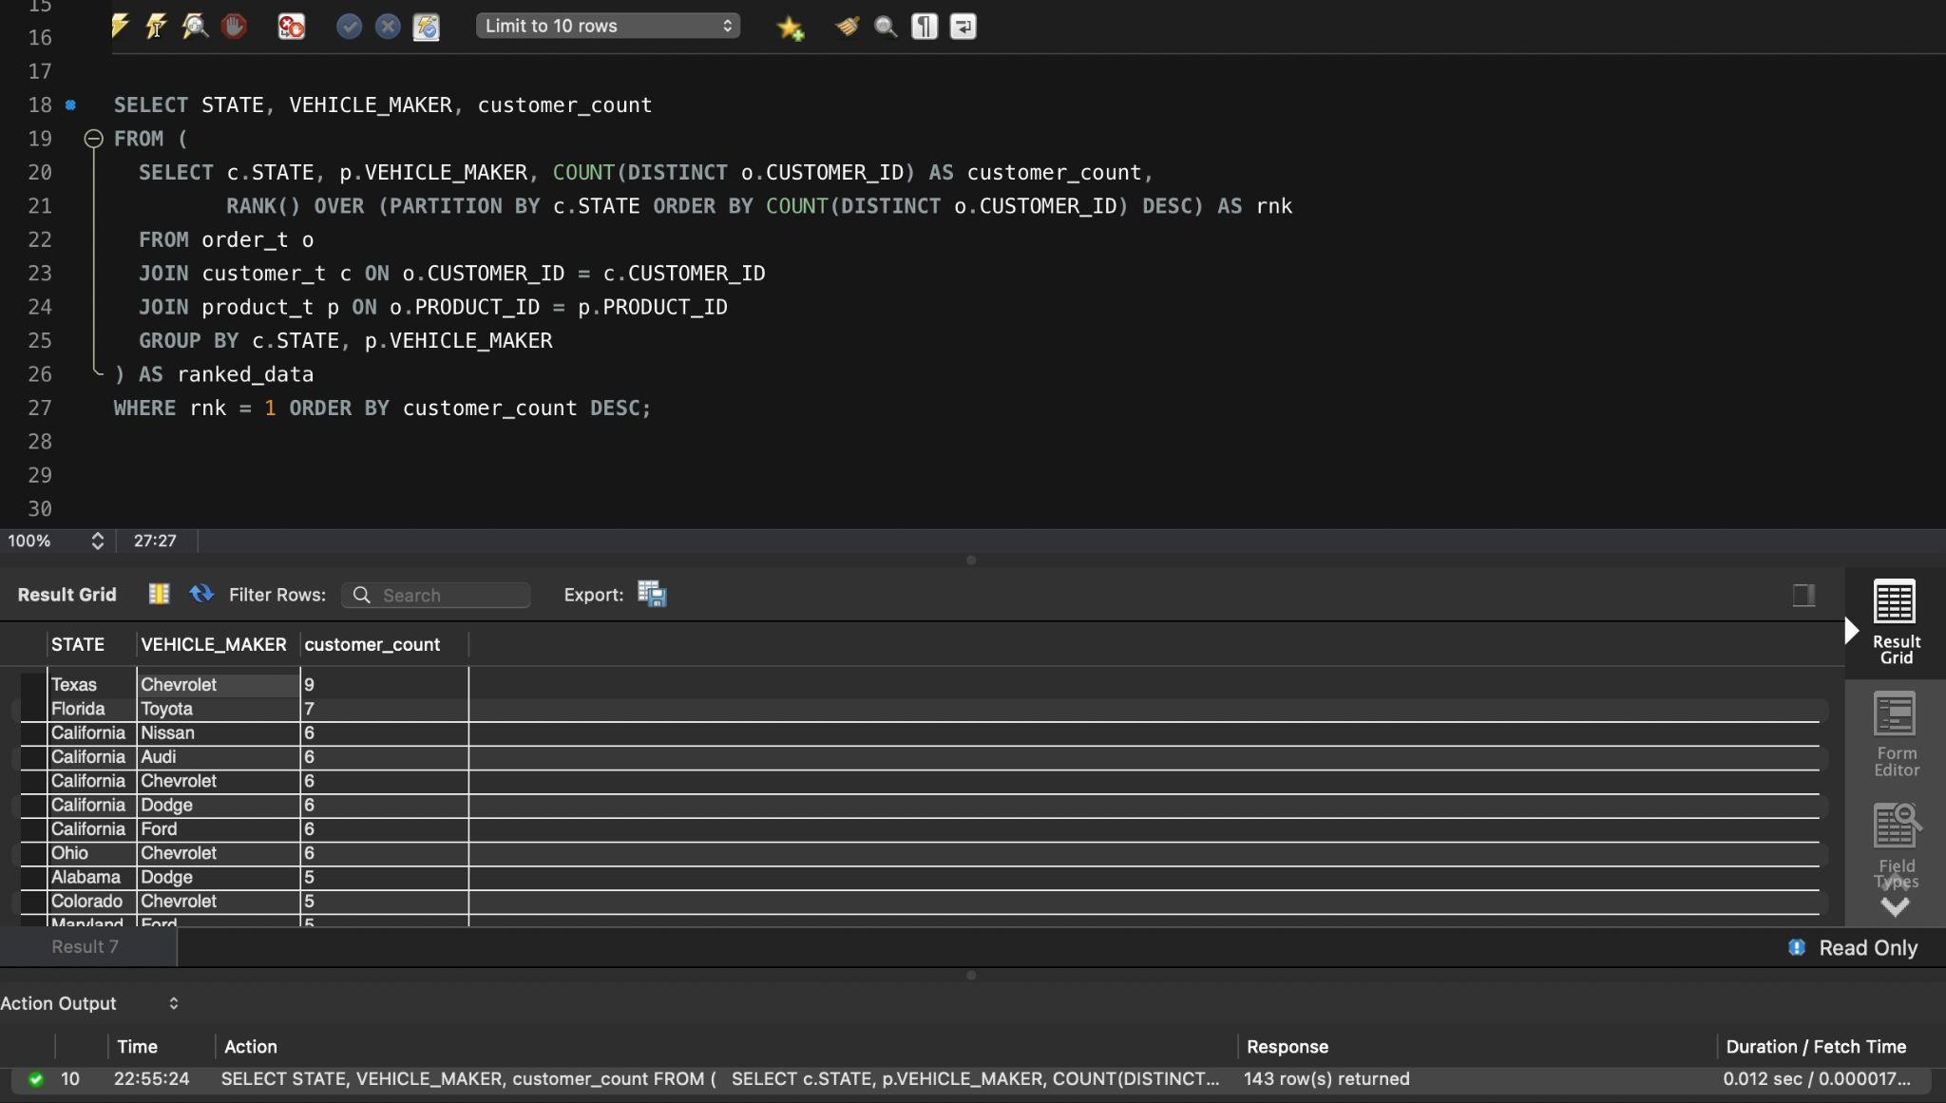

**Observations and Insights:**

* Chevrolet dominates in multiple states (Texas, Ohio, Colorado). Hence can be positioned as a national flagship offering.
* California has high diversity (Audi, Nissan, Dodge, Ford).For California, customized marketing may work better due to varied preferences.

**Question 4: Find the overall average rating given by the customers. What is the average rating in each quarter?**

**Consider the following mapping for ratings: “Very Bad”: 1, “Bad”: 2, “Okay”: 3, “Good”: 4, “Very Good”: 5**

**Solution Query:**

SELECT

ROUND(AVG(CASE CUSTOMER_FEEDBACK

WHEN 'Very Bad' THEN 1

WHEN 'Bad' THEN 2

WHEN 'Okay' THEN 3

WHEN 'Good' THEN 4

WHEN 'Very Good' THEN 5

END), 2) AS overall_avg_rating,

QUARTER_NUMBER,

ROUND(AVG(CASE CUSTOMER_FEEDBACK

WHEN 'Very Bad' THEN 1

WHEN 'Bad' THEN 2

WHEN 'Okay' THEN 3

WHEN 'Good' THEN 4

WHEN 'Very Good' THEN 5

END), 2) AS avg_rating_per_quarter

FROM order_t

GROUP BY QUARTER_NUMBER

ORDER BY QUARTER_NUMBER;

**Output:**

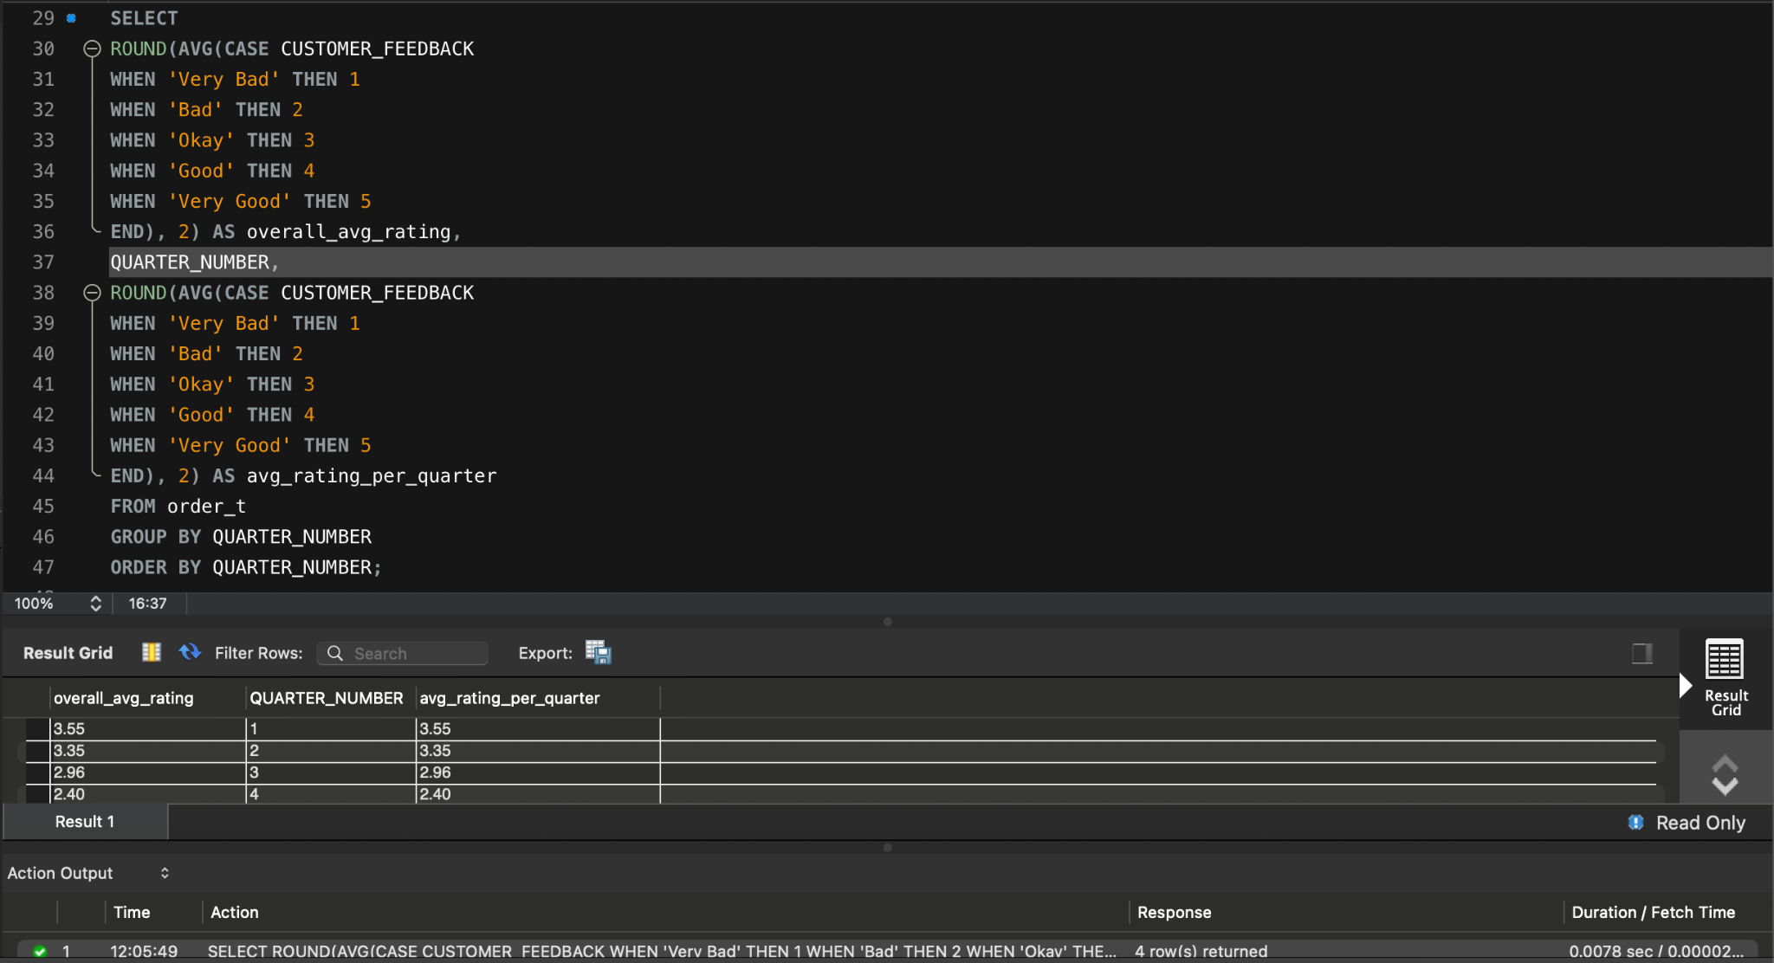

**Observations and Insights:**

* Ratings fall steadily: Q1 (3.55) -> Q4 (2.40) on a scale of 5.
* This confirms a consistent drop in perceived quality or service. An urgent quality assurance review is needed.
* Interventions should be planned to restore customer confidence.

## **Question 5: Find the percentage distribution of feedback from the customers. Are customers getting more dissatisfied over time?**

**Solution Query:**

SELECT

QUARTER_NUMBER,

ROUND(100.0 * SUM(CASE WHEN CUSTOMER_FEEDBACK = 'Very Good' THEN 1 ELSE 0 END) / COUNT(*), 2)

AS pct_very_good,

ROUND(100.0 * SUM(CASE WHEN CUSTOMER_FEEDBACK = 'Good' THEN 1 ELSE 0 END) / COUNT(*), 2) AS

pct_good,

ROUND(100.0 * SUM(CASE WHEN CUSTOMER_FEEDBACK = 'Okay' THEN 1 ELSE 0 END) / COUNT(*), 2) AS

pct_okay,

ROUND(100.0 * SUM(CASE WHEN CUSTOMER_FEEDBACK = 'Bad' THEN 1 ELSE 0 END) / COUNT(*), 2) AS

pct_bad,

ROUND(100.0 * SUM(CASE WHEN CUSTOMER_FEEDBACK = 'Very Bad' THEN 1 ELSE 0 END) / COUNT(*), 2)

AS pct_very_bad

FROM order_t

GROUP BY QUARTER_NUMBER

ORDER BY QUARTER_NUMBER;

**Output:**

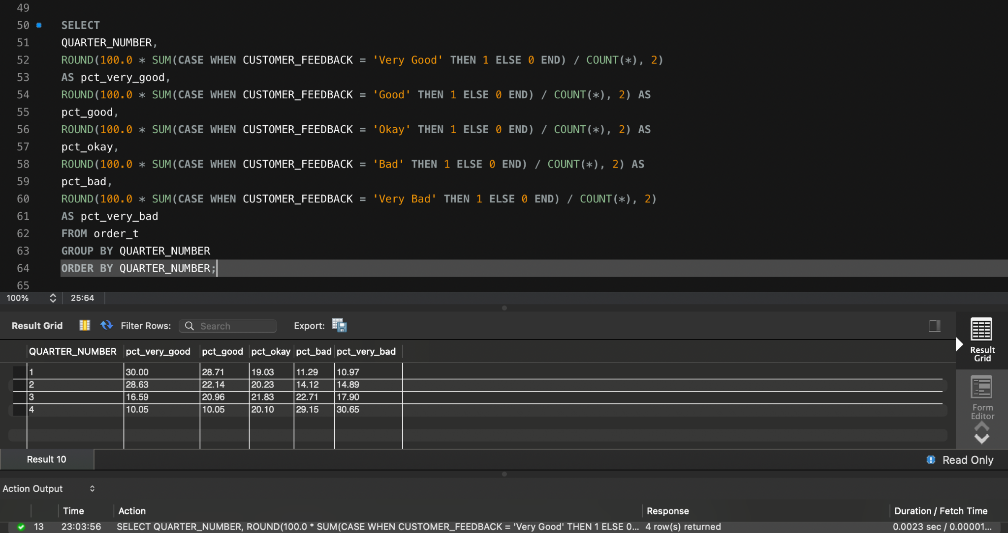

**Observations and Insights:**

* % of “Very Good” feedback drops from 30% in Q1 to 10% in Q4.
* “Bad” and “Very Bad” feedback increases steadily from Q1 to Q4 (11.29% -> 29.15% and 10.97% -> 30.65% respectively).
* There’s a significant decline in customer satisfaction over the quarters.
* Indicates possible operational, logistics, or product quality issues worsening over time.

## 

## **Question 6: What is the trend of the number of orders by quarter?**

**Solution Query:**

SELECT QUARTER_NUMBER, COUNT(*) AS num_orders

FROM order_t

GROUP BY QUARTER_NUMBER

ORDER BY QUARTER_NUMBER;

**Output:**

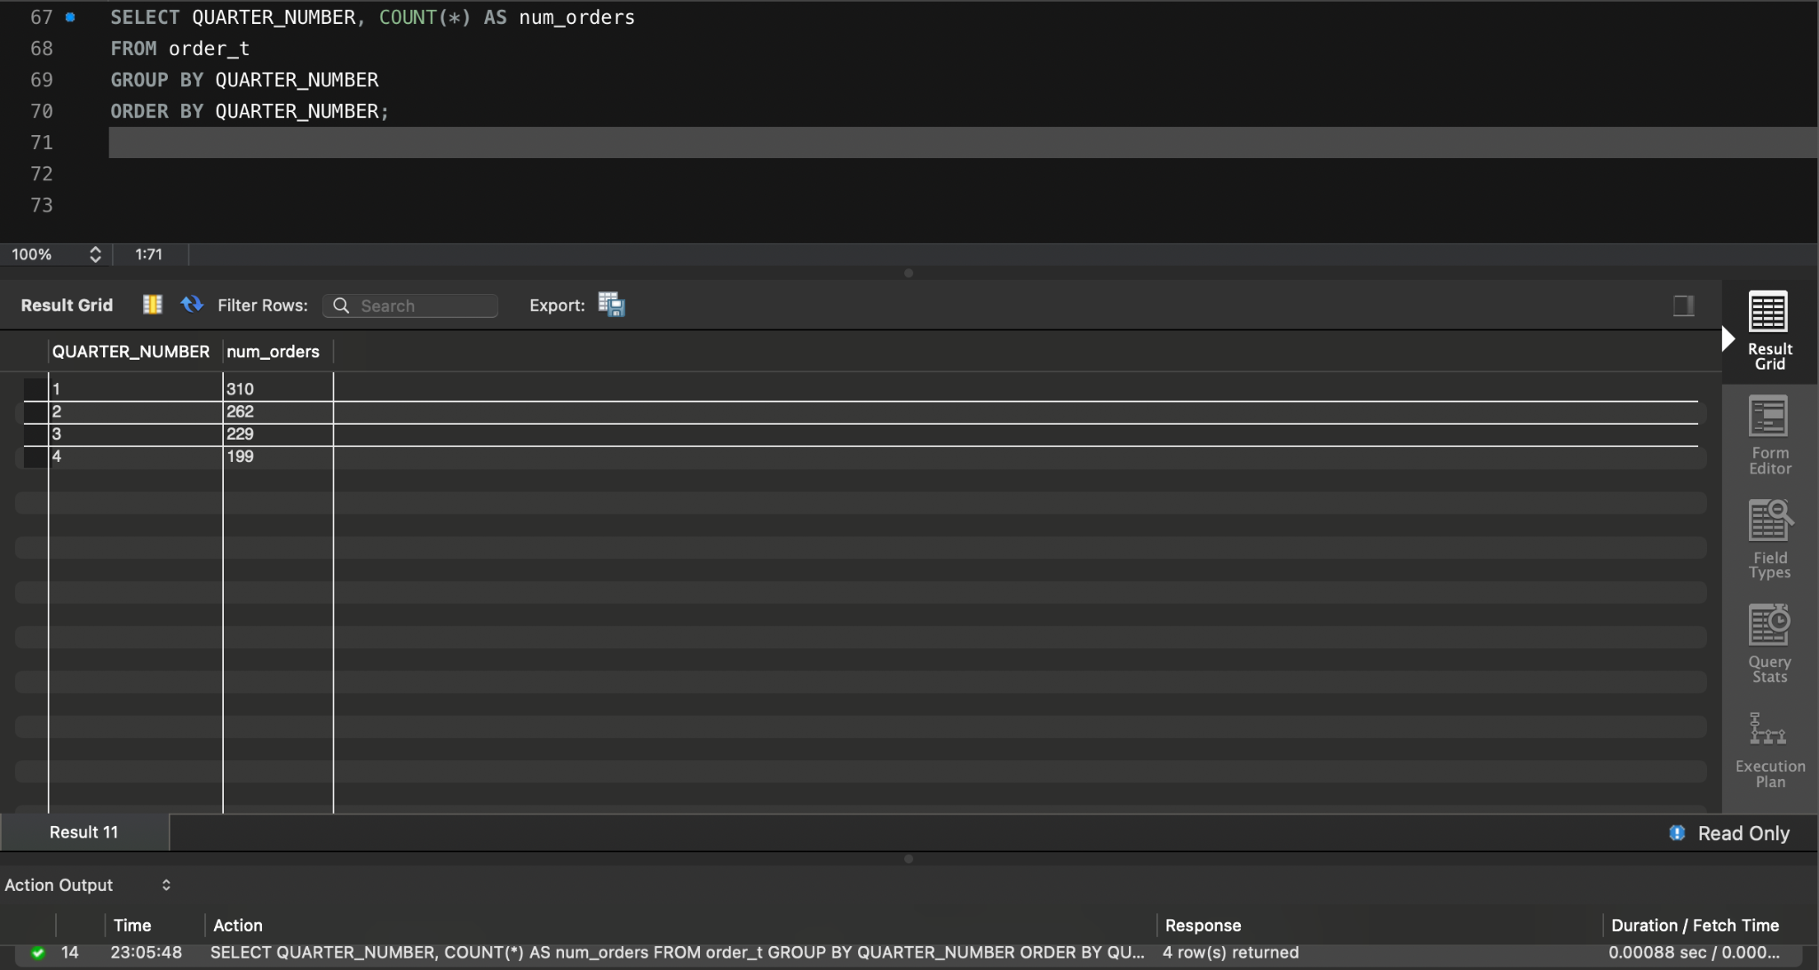

**Observations and Insights:**

* Orders: Q1 (310), Q2 (262), Q3 (229), Q4 (199)
* Direct correlation with revenue decline.
* Reflects reduced customer engagement or demand.
* Marketing campaigns or loyalty incentives may be needed to reverse the downward trend.

## 

## **Question 7: Calculate the net revenue generated by the company. What is the quarter-over-quarter % change in net revenue?**

**Solution Query:**

WITH revenue_per_quarter AS (

SELECT QUARTER_NUMBER,

SUM(QUANTITY * VEHICLE_PRICE * (1 - DISCOUNT / 100)) AS net_revenue

FROM order_t

GROUP BY QUARTER_NUMBER

),

revenue_with_lag AS (

SELECT QUARTER_NUMBER, net_revenue,

LAG(net_revenue) OVER (ORDER BY QUARTER_NUMBER) AS prev_revenue

FROM revenue_per_quarter

)

SELECT QUARTER_NUMBER, net_revenue,

ROUND(100.0 * (net_revenue - prev_revenue) / prev_revenue, 2) AS percent_change

FROM revenue_with_lag;

**Output:**

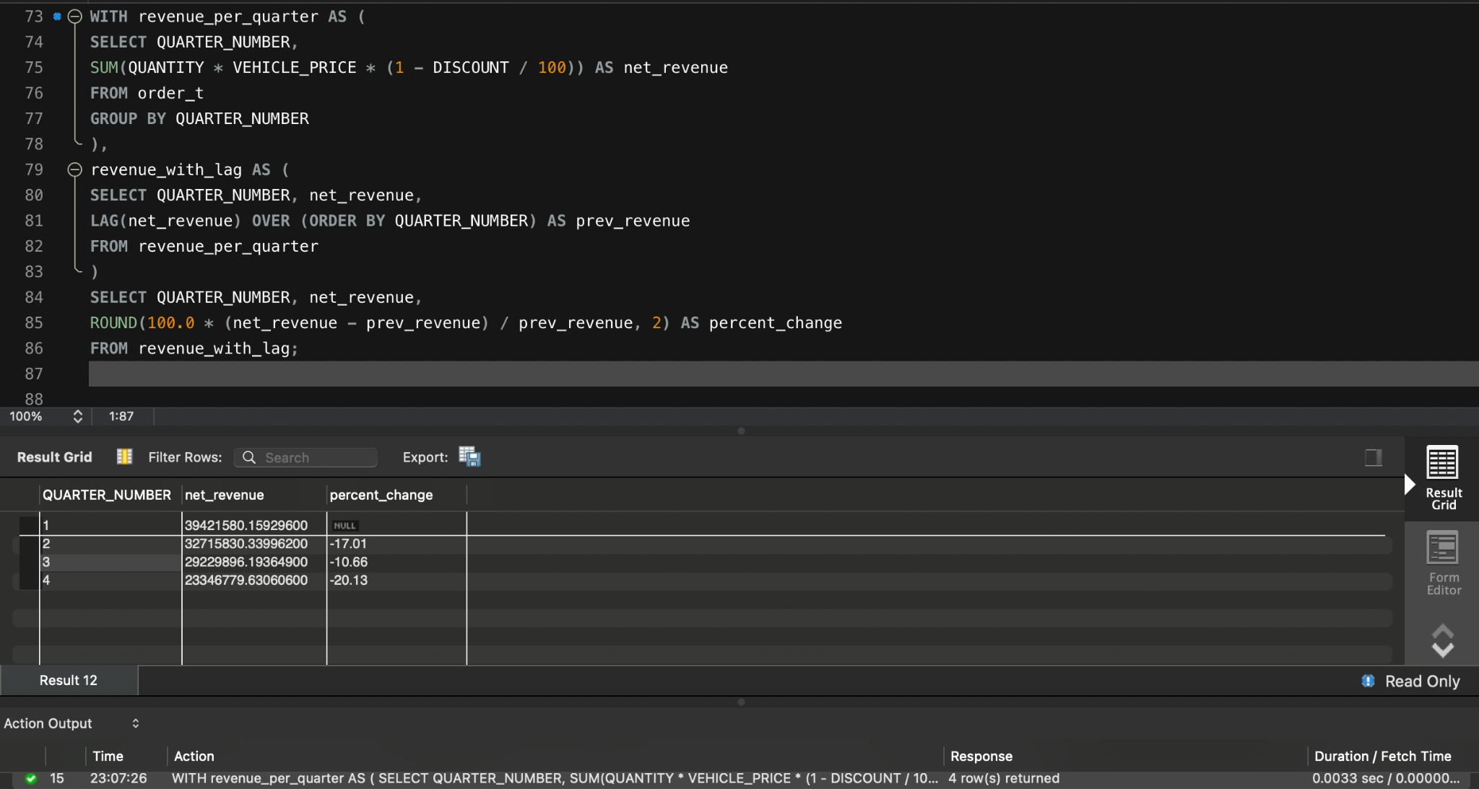

**Observations and Insights:**

* Q1: $39.4M - Q2: $32.7M (decrease by 17.01%) - Q3: $29.2M (decrease by 10.66%) - Q4: $23.3M (decrease by 20.13%)
* Revenue decline is sharp and accelerating in Q4.
* Suggests ineffective promotions or customer retention strategies.
* Investigate if product returns, complaints, or shipment issues correlate with this decline.

## 

## **Question 8: What is the trend of net revenue and orders by quarters?**

**Solution Query:**

SELECT QUARTER_NUMBER,

SUM(QUANTITY * VEHICLE_PRICE * (1 - DISCOUNT / 100)) AS net_revenue,

COUNT(*) AS order_count

FROM order_t

GROUP BY QUARTER_NUMBER

ORDER BY QUARTER_NUMBER;

**Output:**

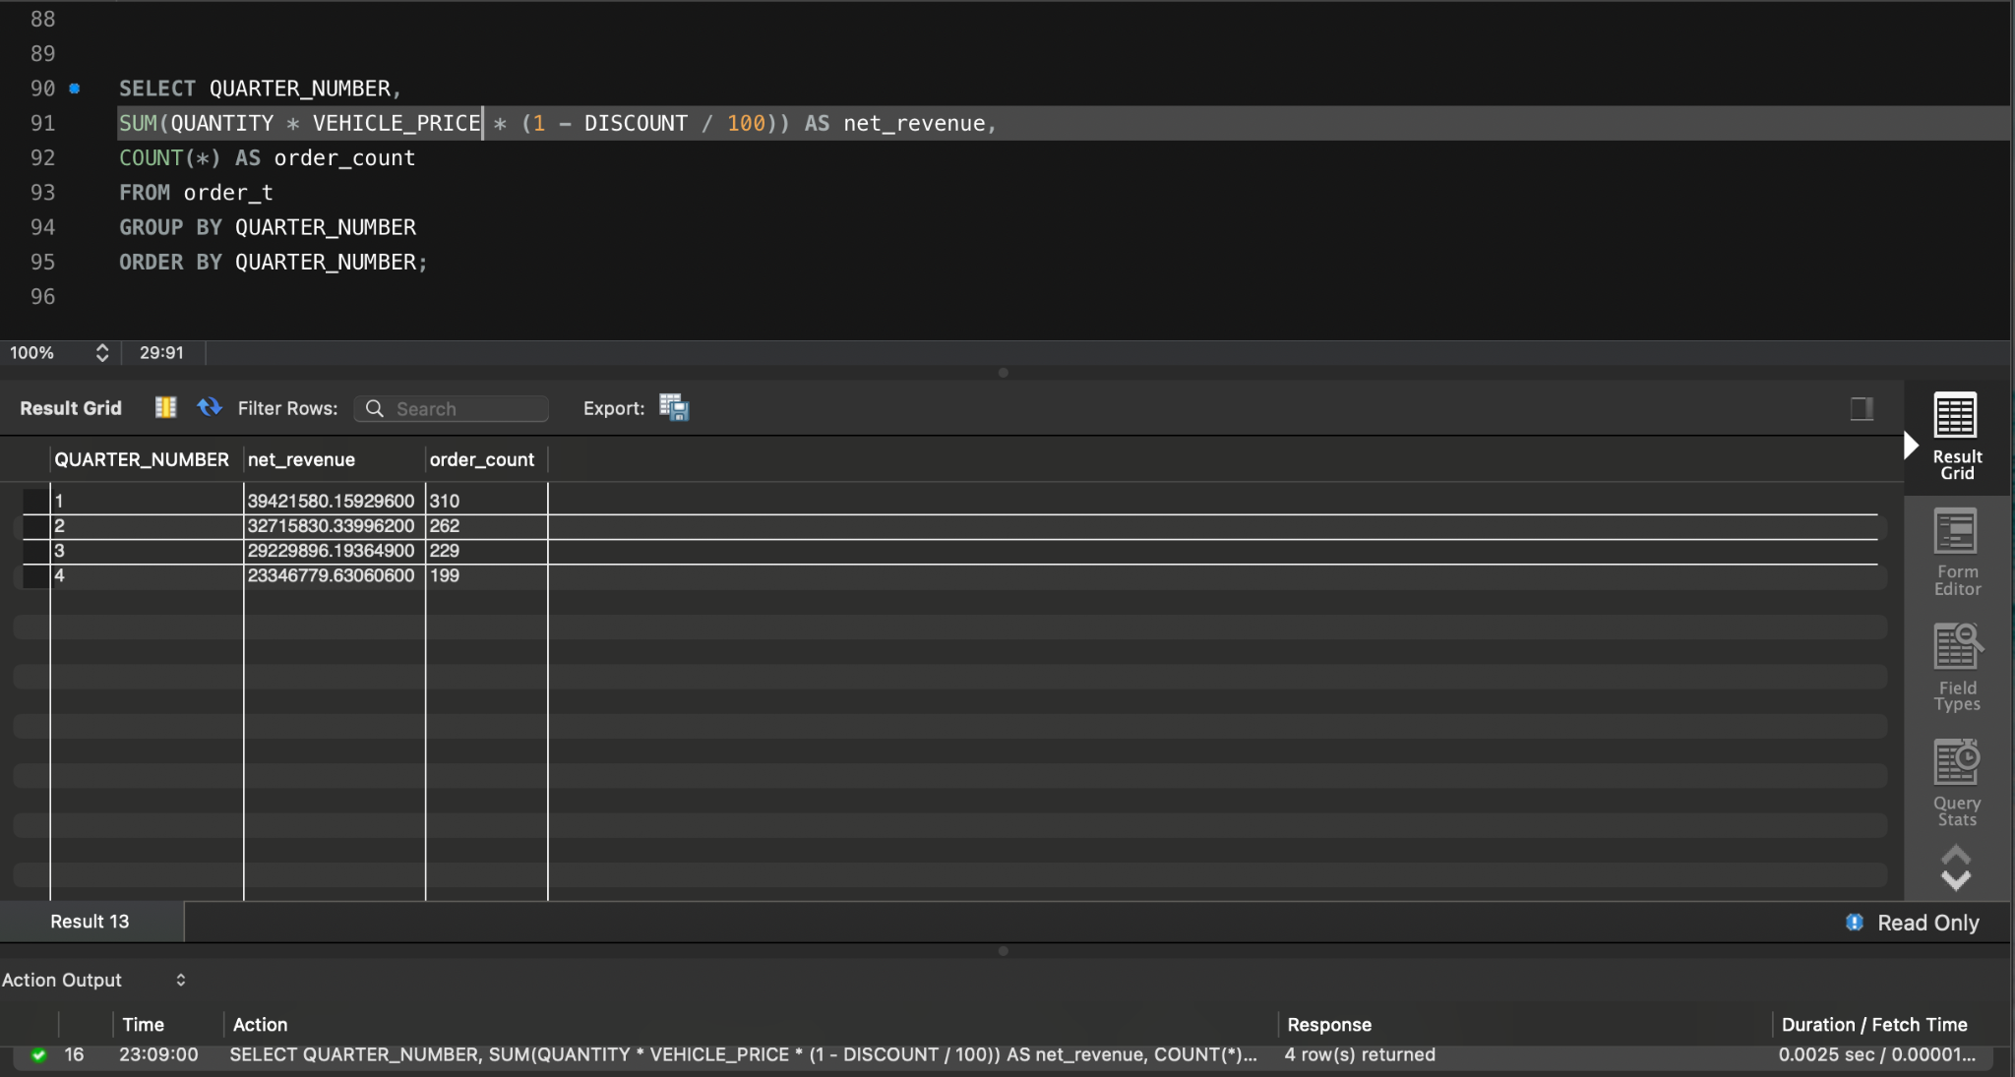

**Observations and Insights:**

* Steep fall: Q1 -> Q4 in both revenue and order count.
* Clear seasonal or systemic downturn.

## 

## **Question 9: What is the average discount offered for different types of credit cards?**

**Solution Query:**

SELECT CREDIT_CARD_TYPE,

ROUND(AVG(o.DISCOUNT), 2) AS avg_discount

FROM customer_t c

JOIN order_t o ON c.CUSTOMER_ID = o.CUSTOMER_ID

GROUP BY CREDIT_CARD_TYPE

ORDER BY avg_discount DESC;

**Output:**

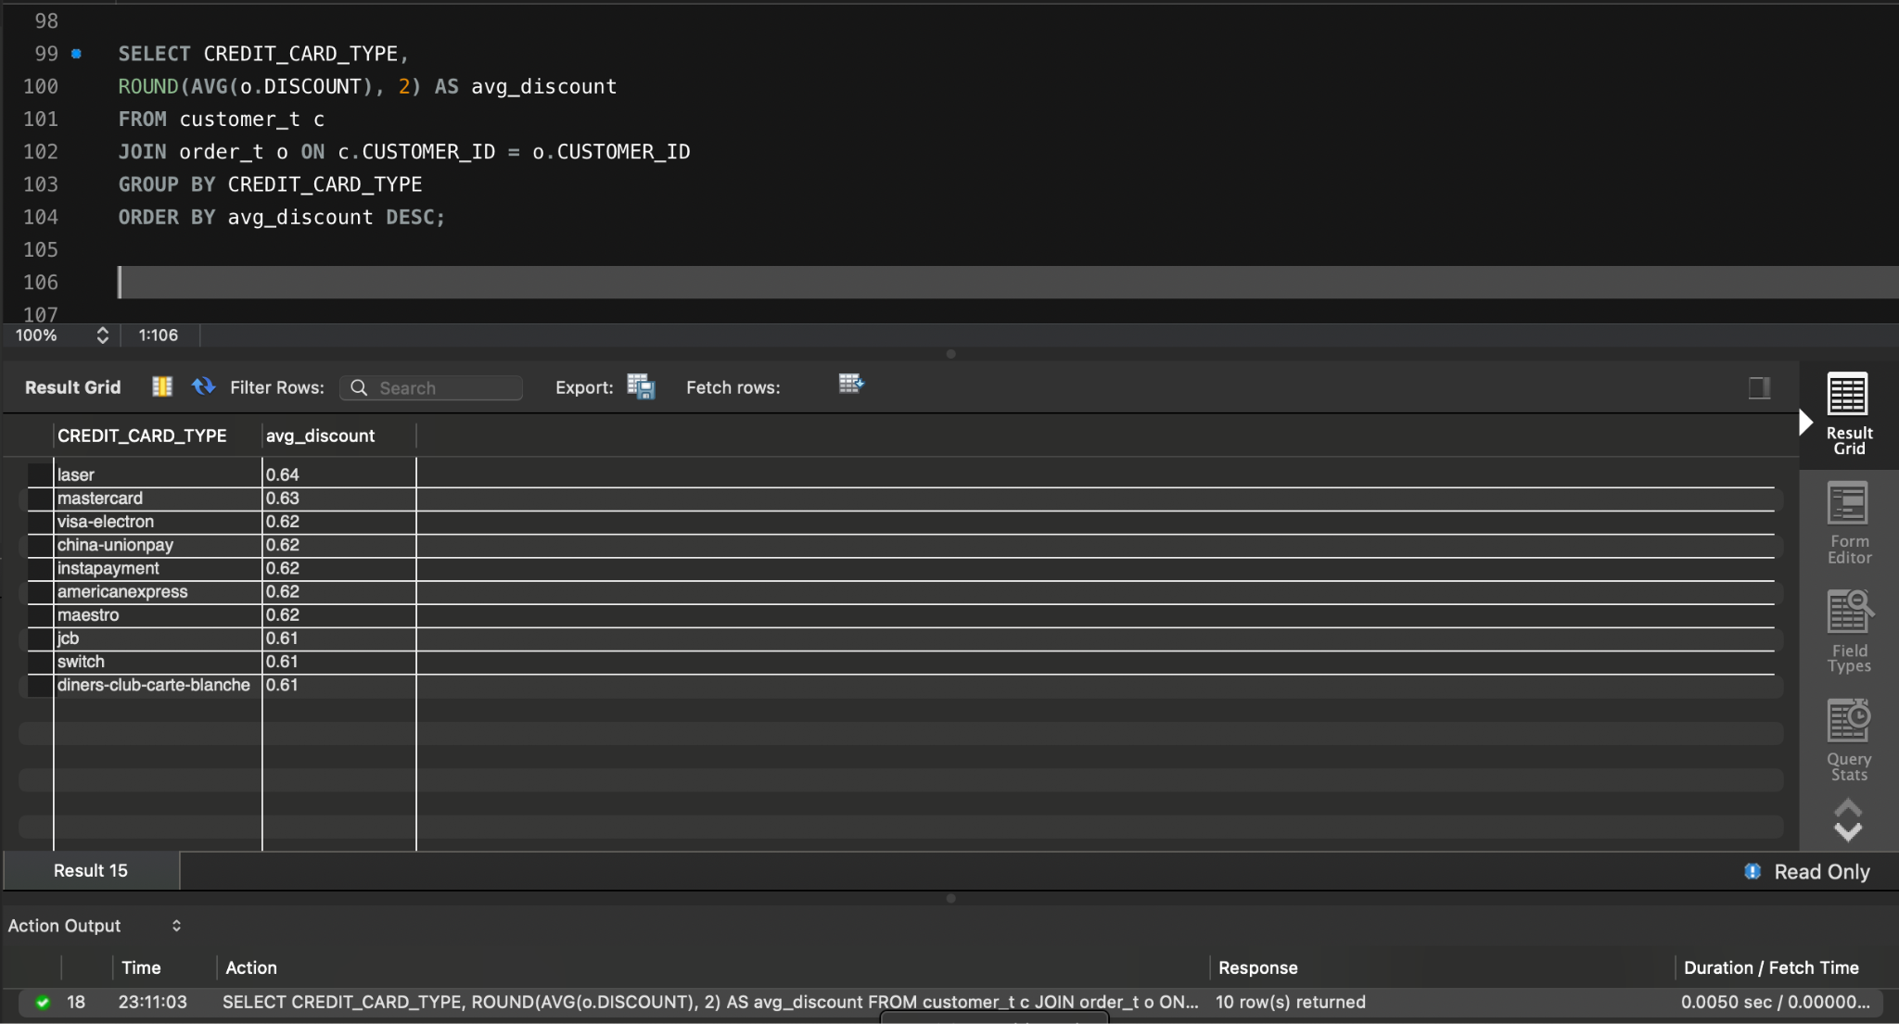

**Observations and Insights:**

* Highest discounts offered for Laser (0.64), Mastercard (0.63), and Visa Electron (0.62).
* Higher discounts on common or premium cards likely aim at volume-based promotions.
* Consider evaluating ROI from these discount programs by correlating with repeat purchases.

## 

## **Question 10: What is the average time taken to ship the placed orders for each quarter?**

**Solution Query:**

SELECT

QUARTER(ORDER_DATE) AS quarter_number,

ROUND(AVG(DATEDIFF(SHIP_DATE, ORDER_DATE)), 2) AS avg_shipping_time

FROM order_t

WHERE ORDER_DATE IS NOT NULL AND SHIP_DATE IS NOT NULL

GROUP BY QUARTER(ORDER_DATE)

ORDER BY QUARTER(ORDER_DATE);

**Output:**

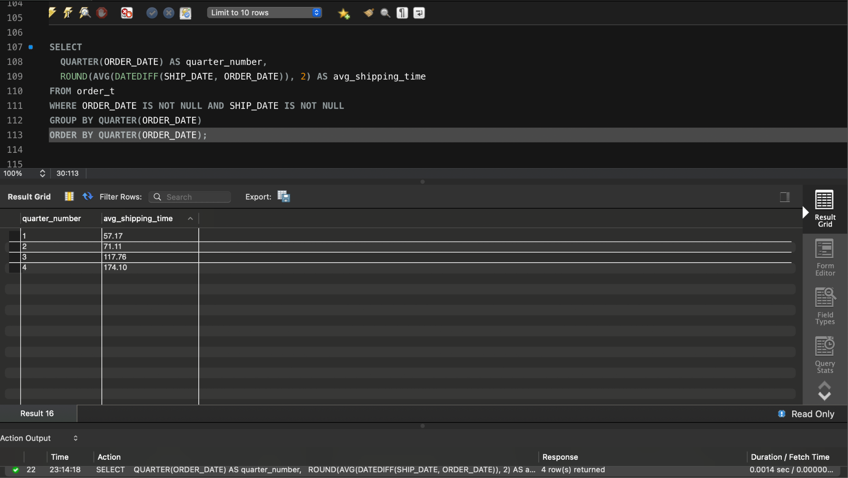

**Observations and Insights:**

* Shipping times increase each quarter: Q1: ~57 days , Q2: ~71 days.
* Inefficiencies in fulfillment growing over time.
* Delays likely contributed to lower feedback and ratings. Invest in logistics improvements or partner evaluations.

# **Business Metrics Overview**

| **Total Revenue** | **Total Orders** | **Total Customers** | **Average Rating** |
| --- | --- | --- | --- |
| $12,47,14,086.32351300 | 1000 | 994 | 3.065 |
| **Last Quarter Revenue** | **Last quarter Orders** | **Average Days to Ship** | **% Good Feedback** |
| $ 2,33,46,779.63060600 | Q4 - 199 | 105 days | 20.5 % |

# **Business Recommendations**

1. **Revenue and Orders Are Declining -** Revenue fell from Q1 to Q4, with Q4 contributing only ~18.7% of total revenue. Orders followed the same trend (Q4 had 199 out of 1000). Run promotional campaigns or seasonal discounts to boost order volume and revive customer interest.
2. **Low Repeat Purchase Rate -** Only a small number of customers placed multiple orders suggesting weak brand loyalty. Launch a loyalty or referral program and send personalized follow-ups to previous customers to drive retention.
3. **Average Customer Rating Has Dropped to 3.065 -** Ratings decreased steadily quarter by quarter, signaling a growing dissatisfaction. Conduct follow-up surveys to identify pain points and invest in after-sales service quality.
4. **Only 20.5% Feedback Is Marked as 'Good' -** This is alarmingly low and directly impacts reputation and referrals. Set up a dedicated customer success team to resolve issues post-purchase and call customers for real-time service recovery.
5. **Average Shipping Time Is 105 Days in Q4 -** This is significantly high and likely driving cancellations and negative feedback. Audit and optimize the logistics pipeline, reduce warehouse delays, streamline approvals, and renegotiate with shipping partners.
6. **Cancellations and Delays Are Rising -** Both metrics have worsened in Q3 and Q4, pointing to broken fulfillment promises. Implement order tracking transparency in the app and proactively notify customers of delays.
7. **Regional Vehicle Maker Preferences Exist -** Use location-based inventory planning and regional promotions to increase relevance and conversion.
8. **End-to-End App Is Central to Operations -** The app is used for everything from listing to shipping. Add "Track My Order", "Live Chat", and "Escalate Issue" features to improve customer control and trust.
9. **Feedback Loop Should Be Real-Time -** Relying on quarterly data means delay in action. Set up a monthly dashboard with key KPIs like shipping time, rating trends, and order volume for faster decisions.
10. **Business Health Is Declining Across Key Metrics -** Orders, revenue, shipping, ratings all show negative trends. Launch a Quarterly Business Health Task Force to review operational, service KPIs, and customer sentiment.
11. **Customer Insights Are Underutilized -** Rich data exists but isn't mined deeply for behavior analysis. Invest in basic predictive analytics to forecast churn, recommend products, and identify upsell opportunities.
12. **High-Value Orders Are Dropping -** Revenue is declining faster than order count, suggesting smaller or discounted purchases. Create premium listings, extended warranties, or service add-ons to boost average order value.
13. **No Indication of Targeted Campaigns -** All marketing appears generic. Use past purchase behavior and region data to run targeted WhatsApp/email/Push campaigns.